12. Namų darbo Nd5 ataskaita

Namų darbo tema
Pristatymo data: 2019-11-30 Atliko: P-8/3R gr. mok. Žilvinas Šmuilys

Dėstytojas : Rimantas Augaitis

2.1 Užduotis
Duotas dvimatis masyvas A(n,n). Pirmoje dvimačio masyvo srityje maksimalų elementą pakeiskite trečios srities neigiamų elementų AV (aritm. vidurkis). Dvimatį masyvą įveskite iš duomenų failo. Dvimatį masyvą spausdinkite rėmeliuose rezultatų faile, numeruojant eilutes ir stulpelius, prieš ir po pertvarkymų bei parodykite ekrane.

2.2 Programos projektas

- Formos schema

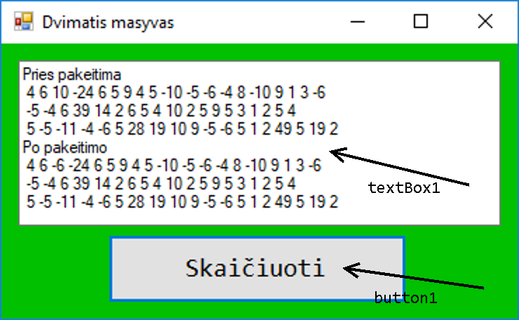

- Programos lango paveikslas

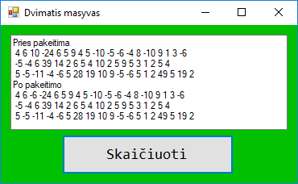

- Keičiamų komponentų savybių lentelė

Komponentas | Savybė (property) | Reikšmė
MyForm | Text  BackColor  Size | Dvimatis masyvas  192, 0, 0  384; 235
button1 | Font  Text | Consolas; 14.25pt  Skaičiuoti
textBox1 | Font | Microsoft Sans Serif, 8.25pt

2.3 Programos tekstas
Funkcijos.cpp
#include "Funkcijos.h"
#include <cmath>
#include <iostream>
#include <fstream>
#include <iomanip>
#include <string>

using namespace std;
int A[256][256];
int a, b = 0;
int c, d = 0;
int n = 0;
int m = 0;
int o = 0;
string u = "";
ofstream fs("rez.txt");
void skait(int A[][256], int &e, int &f)
{
ifstream fd("data.txt");
fd >> c >> d;
while (a < d)
{
while (b < c)
{
fd >> n;
A[a][b] = n;
b++;
}
b = 0;
a++;
}
e = c;
f = d;
}
void calc(int A[][256], int b, double &m)
{
int l = 0;
int k = 0;
double p = 0;
int r = 0;
while (l < c) {
k = A[b][l];
if (k < 0)
{
p += k;
r++;
}
l++;
}
m = (p / r) * 1.0;
}
void calc2(int A[][256], int &b)
{
int l = 0;
int k = 0;
while (l < d) {
k = A[b][l];
if (k > m) m = k;
o = l;
l++;
}
}
void keit(int A[][256], int b, double m)
{
A[b][o] = m;
}
void rodyti(string &text, int A[][256], int a, int b)
{
text = "";
int y = 0;
int j = 0;
while (j < a)
{
y = A[b][j];
u = to_string(y);
text = text + " " + u;
j++;
}
}
void spausd(int A[][256], ofstream &fs)
{
a = 0;
b = 0;
fs << setw(7);
while (b < c)
{
fs << setw(5) << b + 1;
b++;
}
fs << endl;
b = 0;
while (a < d)
{

fs << " ";
while (b < (c * 5) + 1)
{
fs << "-";
b++;
}
fs << endl;
b = 0;
fs << a + 1;
fs << " |";
while (b < c)
{
fs << setw(3) << A[a][b] << setprecision(2) << setw(2) << "|";
b++;
}
fs << endl;
b = 0;
a++;
}
fs << " ";
while (b < (c * 5)+1)
{
fs << "-";
b++;
}
fs << endl;
}
MyForm.h:
#pragma once
#include "Funkcijos.h"

namespace Project2 {

using namespace System;
using namespace System::ComponentModel;
using namespace System::Collections;
using namespace System::Windows::Forms;
using namespace System::Data;
using namespace System::Drawing;
using namespace std;
int A[256][256];
int a, b, c, d, f = 0;
double ee = 0;
std::string text = "";

/// <summary>
/// Summary for MyForm
/// </summary>
public ref class MyForm : public System::Windows::Forms::Form
{
public:
MyForm(void)
{
InitializeComponent();
//
//TODO: Add the constructor code here
//
}

protected:
/// <summary>
/// Clean up any resources being used.
/// </summary>
~MyForm()
{
if (components)
{
delete components;
}
}
private: System::Windows::Forms::TextBox^ textBox1;
private: System::Windows::Forms::Button^ button1;
protected:

private:
/// <summary>
/// Required designer variable.
/// </summary>
System::ComponentModel::Container ^components;

#pragma region Windows Form Designer generated code
/// <summary>
/// Required method for Designer support - do not modify
/// the contents of this method with the code editor.
/// </summary>
void InitializeComponent(void)
{
this->textBox1 = (gcnew System::Windows::Forms::TextBox());
this->button1 = (gcnew System::Windows::Forms::Button());
this->SuspendLayout();
//
// textBox1
//
this->textBox1->Location = System::Drawing::Point(12, 12);
this->textBox1->Multiline = true;
this->textBox1->Name = L"textBox1";
this->textBox1->Size = System::Drawing::Size(344, 118);
this->textBox1->TabIndex = 0;
//
// button1
//
this->button1->Font = (gcnew System::Drawing::Font(L"Consolas", 14.25F, System::Drawing::FontStyle::Regular, System::Drawing::GraphicsUnit::Point,
static_cast<System::Byte>(0)));
this->button1->Location = System::Drawing::Point(76, 136);
this->button1->Name = L"button1";
this->button1->Size = System::Drawing::Size(213, 49);
this->button1->TabIndex = 1;
this->button1->Text = L"Skaičiuoti";
this->button1->UseVisualStyleBackColor = true;
this->button1->Click += gcnew System::EventHandler(this, &MyForm::button1_Click);
//
// MyForm
//
this->AutoScaleDimensions = System::Drawing::SizeF(6, 13);
this->AutoScaleMode = System::Windows::Forms::AutoScaleMode::Font;
this->BackColor = System::Drawing::Color::FromArgb(static_cast<System::Int32>(static_cast<System::Byte>(0)), static_cast<System::Int32>(static_cast<System::Byte>(192)),
static_cast<System::Int32>(static_cast<System::Byte>(0)));
this->ClientSize = System::Drawing::Size(368, 196);
this->Controls->Add(this->button1);
this->Controls->Add(this->textBox1);
this->Name = L"MyForm";
this->Text = L"Dvimatis masyvas";
this->ResumeLayout(false);
this->PerformLayout();

}
#pragma endregion
private: System::Void MyForm_Load(System::Object^ sender, System::EventArgs^ e) {
skait(A, d, f);
}
private: System::Void button1_Click(System::Object^ sender, System::EventArgs^ e) {
ofstream fs("rez.txt");
skait(A, d, f);
fs << "Pries pakeitima:" << endl;
spausd(A, fs);
textBox1->Text += "Pries pakeitima\r\n";
while (a < f)
{
rodyti(text, A, d, a);
textBox1->Text += gcnew String(text.c_str()) + "\r\n";
a++;
}
a = 0;
calc(A, 2, ee);
calc2(A, b);
keit(A, 0, ee);
fs << "Po pakeitimo:" << endl;
spausd(A, fs);
textBox1->Text += "Po pakeitimo\r\n";
while (a < f)
{
rodyti(text, A, d, a);
textBox1->Text += gcnew String(text.c_str()) + "\r\n";
a++;
}
}
};
}

2.4 Duomenys ir rezultatai
Duomenys:
19 3
4 6 10 -24 6 5 9 4 5 -10 -5 -6 -4 8 -10 9 1 3 -6
-5 -4 6 39 14 2 6 5 4 10 2 5 9 5 3 1 2 5 4
5 -5 -11 -4 -6 5 28 19 10 9 -5 -6 5 1 2 49 5 19 2
Rezultatai:
Pries pakeitima:
1 2 3 4 5 6 7 8 9 10 11 12 13 14 15 16 17 18 19
------------------------------------------------------------------------------------------------
1 | 4 | 6 | 10 |-24 | 6 | 5 | 9 | 4 | 5 |-10 | -5 | -6 | -4 | 8 |-10 | 9 | 1 | 3 | -6 |
------------------------------------------------------------------------------------------------
2 | -5 | -4 | 6 | 39 | 14 | 2 | 6 | 5 | 4 | 10 | 2 | 5 | 9 | 5 | 3 | 1 | 2 | 5 | 4 |
------------------------------------------------------------------------------------------------
3 | 5 | -5 |-11 | -4 | -6 | 5 | 28 | 19 | 10 | 9 | -5 | -6 | 5 | 1 | 2 | 49 | 5 | 19 | 2 |
------------------------------------------------------------------------------------------------
Po pakeitimo:
1 2 3 4 5 6 7 8 9 10 11 12 13 14 15 16 17 18 19
------------------------------------------------------------------------------------------------
1 | 4 | 6 | -6 |-24 | 6 | 5 | 9 | 4 | 5 |-10 | -5 | -6 | -4 | 8 |-10 | 9 | 1 | 3 | -6 |
------------------------------------------------------------------------------------------------
2 | -5 | -4 | 6 | 39 | 14 | 2 | 6 | 5 | 4 | 10 | 2 | 5 | 9 | 5 | 3 | 1 | 2 | 5 | 4 |
------------------------------------------------------------------------------------------------
3 | 5 | -5 |-11 | -4 | -6 | 5 | 28 | 19 | 10 | 9 | -5 | -6 | 5 | 1 | 2 | 49 | 5 | 19 | 2 |
------------------------------------------------------------------------------------------------

2019-11-29

